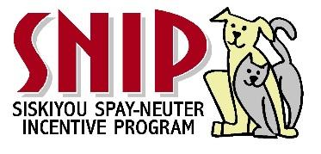
SNIP - Adoption Agreement
NAME: ____________________________ TELEPHONE #: __________________

ADDRESS:__________________________________CITY:___________STATE: ________ZIP: _________

Animal’s Name:__________________________________ DOB/Age:____________ Sex:_____

Description of CAT/KITTEN:________________________________ BREED:_____________________

Email: ____________________________________________________________________________ PLEASE REMEMBER TO FOLLOW THROUGH WITH ALL CAT/KITTEN SHOTS & RABIES
(See paperwork regarding next shot). It is recommended that you also have your kitten tested for feline leukemia at 6 months.
INITIAL EACH ONE BELOW:
______I agree that I am adopting the above-described animal solely as a pet for myself and/or my immediate family. I agree that I will not sell, give away or otherwise dispose of said animal to any person(s) or other entity for any reason without the prior approval of SNIP. ______If at a later date I am unable or unwilling to keep this animal, I agree to contact SNIP and give SNIP the opportunity to take back the pet. I also agree to care for this animal in a humane and responsible manner and to provide it with clean and appropriate shelter, food, water, exercise, companionship and veterinary care.
______ SNIP WILL PROVIDE A $20.00 COUPON TOWARDS THE PETS SPAY OR NEUTER. CALL 926-1196 / WEBSITE FOR COUPON IF THE PET HAS NOT ALREADY BEEN SPAYED OR NEUTERED.
______ I understand that I can return the pet to SNIP within 10 days of the date of this Agreement and SNIP will refund the entire adoption fee paid. I also understand and agree that the adoption fee I paid to SNIP is reasonable and is not refundable after 10 days from the date of this adoption agreement even if I return the animal to SNIP.

______ I understand that SNIP takes every precaution to assure the health of its adoptable animals, but can make NO GUARANTEE of any kind regarding the health and/or temperament of the animal I have adopted. I understand that I, as the adopter, am financially responsible AND liable for the animal upon signing this document.
______ I give my permission for an agent of SNIP to visit the premises where the adopted animal is living, given reasonable notice. I further give permission for a SNIP agent to remove said animal from my premises if SNIP determines that the animal is not receiving appropriate care or if I have violated this agreement. Such entry onto my property shall not constitute trespass upon the premises occupied.

______ I certify that all of the statements made by me on this adoption agreement are true and correct. I agree that SNIP has the right to confiscate the adopted animal in the event that any statements made by me are found to be false and/or my check for the adoption fee is returned for insufficient funds.

Adopter’s Signature: ___________________________________________ Date: __________________
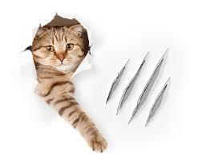
Adoption Fee $___100.00__________ THANK YOU FOR ADOPTING ME!

Additional Donation + __________ PLEASE DONATE: The cost for shelter to get me ready
for adoption is 160.00 and up.

TOTAL PAID $_____________

REMEMBER: I can be returned to SNIP anytime in my life - if at a later date you are unable or unwilling to keep me.
541- 531-1085 – ALISA FRASER
SNIP- 218 EXECUTIVE COURT, YREKA, CA 96097
EMAIL: SISKIYOUSNIP@GMAIL.COM. FACEBOOK PAGE: SNIP of Siskiyou County WEBSITE: SISKIYOUSNIP.ORG

